SCHOOL IMPROVEMENT PLAN
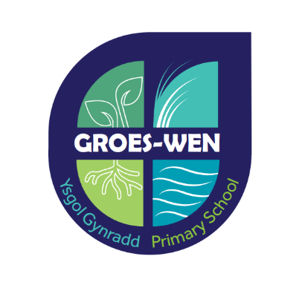

2025 - 2026 (Round 1)

Three Year Vision Ysgol Gynradd Groes-wen Primary School

 | Priority  1a and 1b | Priority 2 | Priority  3a – Establishing a Community  3b – ADY (IQM) | Priority 4
2025 - 2026 | Curriculum for Wales:  Continue to develop concepts in school-wide planning.  Continue to develop an understanding of history, cultural and linguistic heritage, ethnic diversity, identities, experiences and perspectives of their local area, Wales, and the wider world  Further develop the middle plans to include appropriate challenges for pupils in the Over 7 Division.  Focus on pupils' reading skills.  Focus on Maths project – Plasmawr + Welsh Government  Focus on RSE – Plasmawr  Cross-curricular frameworks - focus on digital literacy and competence | Establishing School processes:  Adventurous Area – Continuing to develop the outer area  Children's Rights Scheme – embedding funding processes in lesson planning and developing the children's voice.  Pedagogy – Continuing to develop the FROEBEL principles  - Developing Pupils' Independence  - Setting up Over 7 Department processes  CLIP Work - Assessment for Learning  Assessment Procedures  Track  Silver Award – Children's Rights  Responding to the evaluations and ensuring best practice leads the way. | Community and Relationship:  Further development of school interventions  ALN CPD Training  MAT  Children's Voice  Parent questionnaires  Continue to develop the school's Senedd  Focus on Workload by re-structuring staff responsibilities | School Model:  Continue with the research in order to act on the findings.  Refine the Dual language model as the school develops.
2026 - 2027 | Curriculum for Wales:  Refine our planning processes with a focus on the range of experiences on skills acquisition.  The curriculum design ensures that we celebrate black people and its impact on the life of Cardiff, Wales, Britain and the World.  Continue to establish cross-curricular frameworks – focus on numeracy and continue to embed digital competence. | Evaluation of Wellbeing Processes and use of the Adventurous Area:  Froebel at work within the school.  Silver Award – Children's Rights  Responding to the evaluations and ensuring best practice leads the way. | Community and Relationship:  To further develop the voice of the community.  Further developing children's groups within the Senedd  Measuring the effectiveness of our inclusive processes.  Measuring our success against the IQM report  Staff wellbeing key to school success – education support: Further developing support | School Model:  Action on 2024-25 findings  Voice 21  Phonics strategies  Immersion strategies  Questionnaire for parents.  Using Measurement processes in the use of the Welsh language in the Dual Language Stream
2027 - 2028 | Curriculum for Wales:  Refine our planning processes with a focus on the range of experiences on skills acquisition.  How effective have the cross-curricular frameworks been established? | Evaluating School Processes:  Working towards the Gold award for children's rights  Responding to the evaluations and ensuring best practice leads the way. | Community and Relationship:  To further develop the voice of the community.  Developing children's groups within the Senedd – responding to pupils' questionnaires  Measuring the effectiveness of our inclusive processes.  Measuring our success against the IQM award | School Model:  Action on 2026-27 findings  Questionnaire for parents.  Using Measurement processes in the use of the Welsh language in the Dual Language Stream
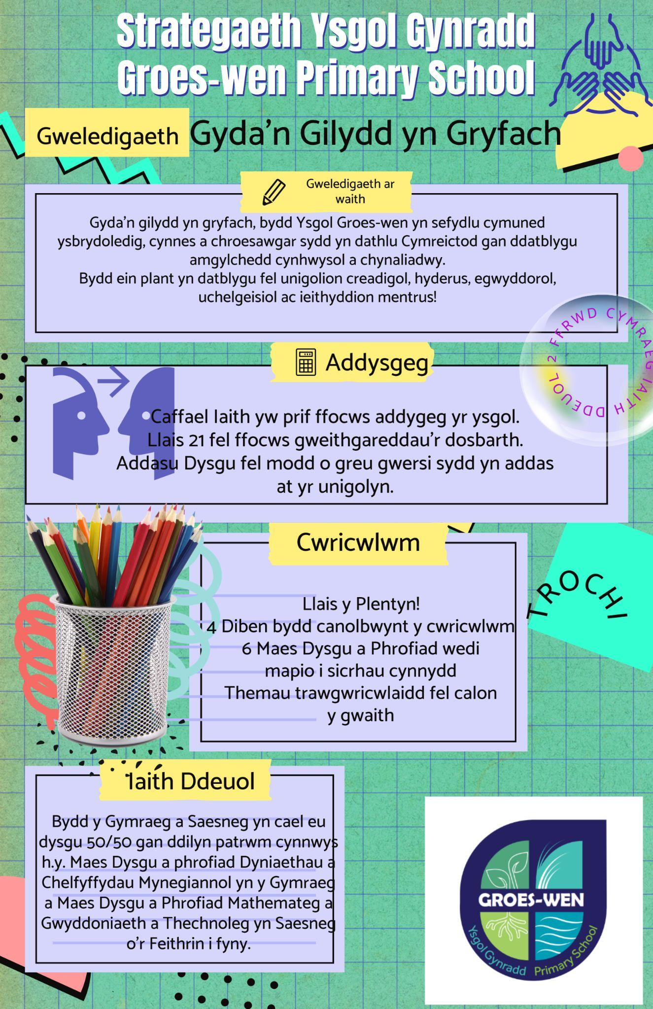
Priority CGY 1: Developing Curricular Processes
Success Criteria: What impact do we want?

- RSE scheme in place at the School and induction process entrenched
- Continue to develop an anti-racist curriculum
- Welsh Government Maths research in action on the classroom floor and improving pupil standards
- National Reading Tests show that most children are making appropriate or better progress
- Cross-curricular frameworks – Literacy skills most pupils show progress taking into account all evidence
Digital Competence Skills are carefully designed to enrich pupils' experiences.

What problem are we trying to solve? To establish a Curriculum for Wales within our planning procedures to ensure the best possible standards for all children in our care.

Staff Voice: What changes will be needed? - Planning, developing reading, rooting the literacy framework and planning digital competence experiences.

Background Reading/Research: Operational Research (YSD Focus): How to design a Curriculum?
Curriculum for Wales - Curriculum for Wales - Hwb (gov.wales)
Dylunio Cwricwlwm CCD - Central South Consortium (google.com)
RSE RSE CODE AND PHASES CYM.xlsx - Dalenni Google
The Curriculum for Wales Relationships and Sexuality Education Code

Mathematics and Numeracy Mathematics and Rhifedd.docx - Google Docs
Maths and Numeracy - Groes-wen Staff - Google Drive
Maths and Numeracy Expectations - Google Docs
Digital:
1] Digital Leadership Pack - Preparation - Google Sites
[2] Digital Assessment | Qualifications Wales
[3] Digital Competence Framework - Hwb

Round 1 | Who co-ordinates the work and Activity (Board Jam) - Supervision: Miss Hughes | Finance/ | Time/ | Blue – Required
 | What changes are needed? | Grant | Date | Make
 |  |  |  | Yellow – In Action
 |  |  |  | Green – Wedi
happen
How will we know if we are getting the desired effect?
Preparation 1 | It is key that we put the newly completed RSE scheme into practice in careful planning – mid-term and weekly.  Set Clear Targets:  Improve understanding of healthy relationships, consent, and sexual well-being.  To improve the consistent opportunities for Relationship and Sexuality Education.  Hold a community evening to discuss the content. |  | September 2025

Preparation 2 | The middle and weekly plans will need to be with reference to historical events and people who support our campaign to develop an anti-racist curriculum.  Set Clear Targets:  Enabling pupils to Access anti-racist resources e.g. reading books, toys celebrating equality and more.  Ensure that pupils have experiences to learn about different people's events and culture including black history  Ensure that pupils have the ability to carry out independent research. |  | September 2025
Preparation 3 | The School is part of Mathematics research with the Welsh Government in conjunction with the Plasmawr cluster. |  | September 2025
Preparation 4 | To develop pupils' reading skills in response to pupils' National test results.  Set Clear Targets:  To enable pupils to raise standards and improve comprehension by ensuring that reading experiences in the classroom are focused on this.  Ensure that pupils have experiences to recall facts or information while reading.  Ensure that pupils have the ability to read independently. |  | September 2025
Preparation 5 | Ensure that cross-curricular literacy tasks raise pupils' standards.  Set Clear Targets:  Assess pupils' ability at the start of the concept in reading, speaking and writing skills as a way of measuring progress by the end of the concept. Re-recite the process to each concept. |  | September 2025
Preparation 6 | When planning, ensure that we plan rich experiences for pupils based on digital application.  Set Clear Targets:  Improving coding skills giving pupils plenty of experience  Ensure pupils have opportunities to use specific software  In developing concepts ensure that pupils have opportunities to develop online research skills. |  | September 2025
Acceleration 1: | - Integration into the Curriculum:  Ensure that the RSE scheme is smoothly integrated into the existing curriculum. This may include cross-curricular projects that use RSE skills in different contexts  - Training and Support:  Provide training to Teachers on the use of RSE strategies and assessment methods. Ensure support is available for pupils who need additional support  - Monitoring and Evaluation: Regularly monitoring pupils' progress and evaluating the effectiveness of the scheme. Adjust the strategies as needed to ensure that the goals are achieved  - Community Involvement: Ensure parents and the wider community are involved in the process. This may include information sessions for parents and opportunities to discuss the RSE programme. |  | September 2025  October 2025  December 2025  Autumn Term 2025
Acceleration 2: | - Integration into the Curriculum:  Ensure that the anti-racist documents are smoothly integrated into the existing curriculum. This may include cross-curricular projects.  - Training and Support:  Provide training for teachers - DARPL  - Monitoring and Evaluation: Regularly monitoring pupils' progress and evaluating the effectiveness of the scheme. Adjust the strategies as needed to ensure that the goals are achieved  Community Involvement: Ensure parents and the wider community are involved in the process. This can include information sessions for parents and opportunities to discuss the anti-racist program with a focus on diversity and diversity. |  | September 2025  October 2025  December 2025  Autumn Term 2025
Acceleration 2: | MATHEMATICS
Acceleration 3: | - Choosing Reading Strategies:  It will be important that the Teachers offer a variety of effective reading strategies such as active reading, contextual reading, and the use of memory techniques. Using resources such as books, articles, and interactive materials can also be helpful  - Training and Support:  Provide training to teachers on the reading strategies and assessment methods. Make sure support is available for pupils who need additional support.  - Monitoring and Evaluation:  Regularly monitor pupils' progress and evaluate the effectiveness of the scheme. Adjust the strategies as needed to ensure that the goals are achieved.  - Encourage Independent Reading:  Create opportunities for pupils to practise reading independently by providing various books and reading materials. It can also be useful in encouraging reading for pleasure and creating a supportive reading environment at home and at school. |  | September 2025  October 2025  December 2025  Autumn Term 2025
Acceleration 4: | - Integration into the Curriculum:  Ensure that the literacy framework is smoothly integrated into the existing curriculum. This may include cross-curricular projects using literacy skills in different contexts  - Training and Support:  Provide training to teachers on the use of literacy strategies and assessment methods. Make sure support is available for pupils who need additional support.  - Monitoring and Evaluation:  Regularly monitor pupils' progress and evaluate the effectiveness of the scheme. Adjust the strategies as needed to ensure that the goals are achieved.  - Encourage Independent Use:  To create opportunities for pupils to practise their literacy skills independently by providing projects and activities that encourage them to use these skills in innovative ways. |  | September 2025  October 2025  December 2025  Autumn Term 2025

Acceleration 5: | - Select Suitable Resources:  Ensuring that we make effective use of the software available on HWB  Make effective use of hardware including coding robots.  - Integration into the Curriculum:  Ensure that the digital experiences are smoothly integrated into the existing curriculum. This may include cross-curricular projects that use technology to solve real problems.  Monitoring and Evaluation:  Regularly monitor pupils' progress and evaluate the effectiveness of the scheme. Adjust the strategies as needed to ensure that the goals are achieved.  - Encourage Independent Use:  To create opportunities for pupils to practise their digital skills independently by providing projects and activities that encourage them to use technology in innovative ways. |  | September 2025  October 2025  December 2025  Autumn Term 2025
Evaluation: How will we know if we are having the desired impact?

Priority CGY 2: Setting Up School Processes
Success Criteria: What impact do we want?
- CLIP work – assessment and progression rooted with a focus on one aspect of the curriculum – Language, Literacy and Communication
- Froebel's pedagogy to be seen in action especially in the early years
- To establish the processes of the children's rights prize money in the way we plan all aspects of school life
What problem are we trying to solve? Implementing and harmonising school processes

Staff Voice: What changes will be needed? Tracking Processes and progress.

Background Reading/Research:
Assessment Work – Spiral of enquiry: What is effective assessment and tracking? Operational Research: Assessment for Learning
Froebel: Layout 1 (froebel.org.uk)
Adaptive Teaching (Sgaffaldi) file:///C:/Users/Teacher/OneDrive%20-%20Hwb/Documents/Groes-wen/Understanding-Adaptive-Teaching-v11.pdf
EEF blog: Moving from ‘differentiation’ to ‘adaptive teaching’ | EEF (educationendowmentfoundation.org.uk)
Round 1 | Who co-ordinates the work and Activity (Jam Board) Supervision: Mrs Rhisiart | Finance/ | Time/ | Blue – Required
 | What changes are needed? | Grant | Date | Make
 |  |  |  | Yellow – In Action
 |  |  |  | Green – Wedi
happen
How will we know if we are getting the desired effect?
Preparation 1 | CLIP WORK:  Ysgol Berllan Deg, Ysgol Gwaelod y Garth, Ysgol Creigiau, Ysgol Treganna and Ysgol Groes-wen will work collaboratively on the development of tracking, progress and impact measurement systems.  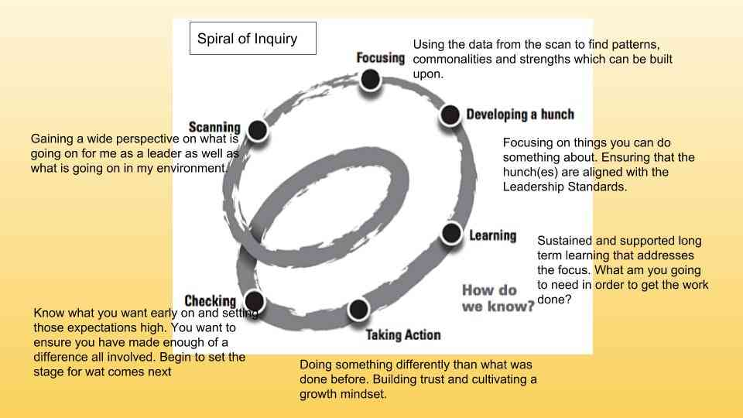  - Scanning: Start by assessing existing literacy tracking skills and areas where improvement is needed.  - Focus: Define specific, measurable, and achievable goals for improving literacy tracking systems. |  | September 2025

Preparation 2 | Develop the Froebel principles in the Reception Class.
Preparation 3 | Working towards the Gold Award ensuring that the School roots all funding processes moving forward.  Working towards Gold: Rights Respecting - Unicef UK  - Set Clear Targets: ensure that all Members of staff, all pupils are aware of their rights and how to use them and how to plan for them.  Referring to the targets of the Silver Award report:
Acceleration 1: | RESEARCH: Spiral on Enquiry  - Development: Use an effective tracking system to monitor pupils' progress (this may be different for each School). This can include progress tracking software or customized spreadsheets to record performance data  - Learning and Action - Regular Data Collection: Collect regular data on pupils' performance through tests, observations, and classroom work. Ensure that the data is collected consistently and accurately. Analyze the data to identify trends and areas where improvement is needed. Use this information to adapt the learning strategies and lesson plans.  - Check - Reporting and Communication: Report progress to pupils, parents, and staff. Use the data to show progress and identify areas where additional support is needed.  - Check – Evaluate Impact: Evaluate the impact of the strategies used to improve literacy. Use the results to make necessary changes to the improvement plan.  - Training and Support: Provide training to teachers and staff on the use of the tracking system and assessment methods. Make sure support is available for pupils who need additional support. |  | October 2025  All Seasons  At the end of each season.  Summer Term
Acceleration 2: | FROEBEL
Acceleration 3: | Gold Award:  - Choose Suitable Resources: Use resources such as posters, brochures, and interactive materials to enrich the learning experiences. It is important that the resources are inclusive and reflect a diversity of identities and experiences.  - Integration into the Curriculum: Ensure that the children's rights scheme is smoothly integrated into the existing curriculum. This may include cross-curricular projects that use children's rights in different contexts.  - Training and Support: Provide training to teachers and staff on the use of children's rights strategies and assessment methods. Make sure support is available for pupils who need additional support.  - Monitoring and Evaluation: Regularly monitoring pupils' progress and evaluating the effectiveness of the scheme. Adjust the strategies as needed to ensure that the goals are achieved.  - Community Involvement: Ensure parents and the wider community are involved in the process. This may include information sessions for parents and opportunities to discuss the children's rights programme.  - Use Rights Language: Use rights language in your daily practice with children and their families. |  | September 2025  Autumn Term  Timetable in place Autumn Term  At the end of each season  Spring Term  Continually
Evaluation: How will we know if we are having the desired impact?

Priority CGY 3: Community and Relationships - IQM/ALN Scheme
Success Criteria: What impact do we want?
- Setting up a new CADY
- Interventions lead to continuous improvement ensuring progress
- CPD training programme improves awareness of all staff

What problem are we trying to solve? Setting up a new CADY

Staff Voice: What changes will be needed? Continue to work on IQM's recommendations

Background Reading/Research: Operational Research (YSD Focus):ALN -
:ADYaCh - Additional Learning Needs Co-ordinator (CADY)

Round 1 | Who co-ordinates the work and Activity (Jam Board) Supervision Mrs Llwyd | Finance/ | Time/ | Blue – Required
 | What changes are needed? | Grant | Date | Make
 |  |  |  | Yellow – In Action
 |  |  |  | Green – Wedi
happen
How will we know if we are getting the desired effect?
Preparation 1 | - Set Clear Targets:  Define specific, measurable, and achievable goals for the new CAD. For example, improving the process of identifying additional learning needs or improving support for pupils with ALN. |  | September 2025

Preparation 2 | Interventions lead to continuous improvement ensuring progress. |  | September – October 2025
Preparation 3 | Forming a CPD training programme following the needs of staff to respond to what pupils need. |  | Autumn Term
Acceleration 1: | Selecting a Suitable Person: Ensure that you select an individual with the appropriate skills and experience to carry out the CADY role. This can include experience in education, knowledge of ALN, and the ability to work effectively with staff, pupils, and parents.  Training and Support: Provide the new CADY with comprehensive training on ALN policies and procedures, as well as the tracking systems and assessment methods used in your School.  Integration into the Curriculum: Ensure that the CADY works closely with the teachers to smoothly integrate ALN strategies into the existing curriculum. This may include planning lessons that take into account additional learning needs and providing suitable resources.  Monitoring and Evaluation: Regularly monitoring the progress of pupils with ALN and evaluating the effectiveness of the strategies used. Use this data to make necessary changes to the improvement plan. |  | December 2025
Acceleration 2: | Suitable Interventions: Ensure that you choose interventions that are suitable and appropriate to raise pupil standards.  Training and Support: Provide comprehensive training to intervention staff on ALN policies and procedures, as well as the tracking systems and assessment methods used in your School.  Integration into the Curriculum: Ensure that the CADY works closely with the teachers to smoothly integrate ALN strategies into the existing curriculum.  Monitoring and Evaluation: Regularly monitoring the progress of pupils with ALN and evaluating the effectiveness of the strategies used. Use this data to make necessary changes to the improvement plan. |  | Autumn Term  At the end of each season
Acceleration 3: | CPD training in place. |  | Autumn Term

Evaluation: How will we know if we are having the desired impact?

Priority CGY 4: Model Groes-wen
Success Criteria: What impact do we want?
- All children develop confidence as Welsh speakers
- Voice 21 has a very positive impact on pupils' speaking ability
- An immersion timetable firmly in place and having an impact on pupils' ability
- Cardiff MET research

What problem are we trying to solve? To continue to refine our school processes

Staff Voice: What changes will be needed? Implementing Voice 21 strategies more consistently

Background Reading/Research: Operational Research (YSD Focus):GO Literacy Platform - Voice Resources 21
: Our Voice - GwE Oracy Project

Iaith Ddeuol - Dual Language 5050 Models.pdf
OECD_Learning_Compass_2030_Concept_Note_Series (1).pdf
trochi-hwyr-a-darpariaeth-ieithyddol-ddwys-adolygiad-cwmpasu-cyflym_0.pdf
Llyfryn-Dulliau-Addysgu-Dwyieithog-CY.pdf
GuidingPrinciplesforDualLanguageEducation3rdeditionREV.pdf
GomezFreemanarticle.pdf
Round 1 | Who Coordinates the Work and Activity (Board Jam) Mr Carbis Supervision | Finance/ | Time/ | Blue – Required
 | What changes are needed? | Grant | Date | Make
 |  |  |  | Yellow – In Action
 |  |  |  | Green – Wedi
happen
How will we know if we are getting the desired effect?
Preparation 1 | Ensure that all classes plan opportunities to develop our pupils' oral skills. – Voice 21 will allow us to create a structured programme.  Set Clear Targets:  Improve the ability to express ideas clearly,  Developing active listening skills  Boosting confidence when speaking in public. |  | Autumn Term

Preparation 2 | A new member of staff will need to be trained to support pupils with immersion work. |  | September 2025
Preparation 3 | Cardiff Met Research led by Dr Mirain Rhys |  | September 2025 onwards
Acceleration 1: | Voice 21 | Oracy | United Kingdom  Select Suitable Resources: Use resources such as those provided by Llais 21, which include activities and strategies to improve oracy skills. This can include discussion activities, role-playing, and collaborative tasks  Curriculum Integration: Ensure that the Llais 21 scheme is smoothly integrated into the existing curriculum. This may include cross-curricular projects that use oracy skills in different contexts  Training and Support: Provide training to teachers and staff on the use of Voice 21 strategies and assessment methods. Make sure support is available for pupils who need additional support.  Monitoring and Evaluation: Regularly monitoring pupils' progress and evaluating the effectiveness of the scheme. Adjust the strategies as needed to ensure that the goals are achieved.  Community Involvement: Ensure parents and the wider community are involved in the process. This can include information sessions for parents and opportunities to discuss the Llais 21 programme.  Use Spoken Language: Use our language continuum every day. |  | October 2025 onwards
Acceleration 2: | An immersion training programme in place to support a new member of staff to lead on immersion. |  | September 2025 onwards
Acceleration 3: | The University will contact the School to say what are the next steps we need to follow. |  | September 2025 onwards

Acceleration 5: | Cardiff Met's research continues under the leadership of Dr Mirain Rhys, this will include staff interviews, parent questionnaires, classroom observations. |  | September 2024 onwards
Evaluation: How will we know if we are having the desired impact?

